ZHSystems Design Document
Version 1.0

1 | Initial version | 08/20/2010 | Venkat .S

Purpose:

The purpose of this document is to analyze and describe the Health Care industry entities and their relationships. This document primarily focuses on Hospital Management of day to day operations. Managing appointments, patient’s information, visitations, medications etc. are difficult to handle manually. An automated system is needed that fulfills all these necessaries.

Target Hospitals: Basic-Medium size hospitals in India. These kinds of hospitals may have 5-10 doctors and 20-30 assistants.

Introduction:

A hospital has several doctors with specializations and also has several assistants/nurses. There may be possibility of having short term care units such as wards. The doctor service several patients in a day. Some patients can be in-patients and/or some can be out-patients.
The assistants take care of initial registration of patient’s information, checking of blood pressure, weight etc. In each visitation the doctor can prescribes medication and also prepares notes/details. The patient may pay the fee for the treatment.

ER-Diagram:

Based on the information in previous section below is ER Digram:

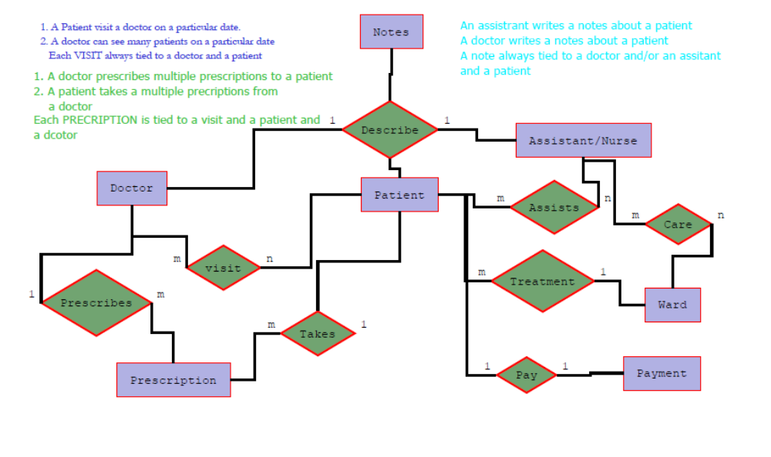

First patient visits the hospital

Search for the patient in the Hospital Systems

If Patient record not exists

{

1. New Patient
a. Nurse/Assistant creates the new Patient Record with following information.
- Enter all patient information
- Assign a doctor to patient
- Creates the patient Record with Unique Patient id
- Enter Allergies (May be not here)

b. Creates the New visit

- Patient Visit Information (Role: Nurse)
- Reason for Visit
- Enter Height and Weight
- Vitals (Temperature, heart rate, BP, etc….)

- Patient History (Role: Nurse)
- Problems History
- Family History
- Medical History (between visit, if the patient visits another doctor, and if the surgical, medical history changes)
- Social History

- Prescriptions (Role: Doctor)
- Prescribes medications / Injections
- Enter Descriptions of the medications
- Show the allergies here to see the doctor while prescribing the medications

- Notes (Role: Doctor)
- Enter notes (doctor patient discussion)

-Lab Records (Role: Doctor/Nurse)
- Request for Lab tests
- Patient Lab records
- X-Rays
- Scanned documents (if any)
}

Old Patient:
- Go to b. Creates the New visit

Patient Registration:

Patient Information:
MedRecNum
last_name
first name

USER
ID
ROLE_ID (Foreign key of role table)
Username
Password

ROLE
ID
- Name ( Unique name for role)
- Description
- Funtional_ID (foreign key of functional area ID).

FuntionalArea
- ID
- Description ( anything : any department name)

